COMP 342: Data Communications and Networking
Spring 2025

Project 1: Reliable Data Communication

Date Released: 2/26/2025

Assignment: In this project, you will implement a socket-based client-server communication system to transmit data reliably using Stop-and-Wait ARQ and Selective-Repeat ARQ flow control methods.

The server listens on port 8080, waiting for incoming data from the client. Once all packets are received, the server assembles them into a file and saves it locally.
The client connects to the server using its IP address, then splits a file into multiple packets and transmits them using either the Stop-and-Wait ARQ or Selective-Repeat ARQ flow control method. The client also simulates network issues, including damaged packets and lost packets:
- In Stop-and-Wait ARQ, each packet has a chance of being damaged.
- In Selective-Repeat ARQ, packets may be lost during transmission.

To ensure reliable communication, the ARQ methods must handle these issues effectively.
Each packet follows a customized BISYNCPacket structure, as shown below:
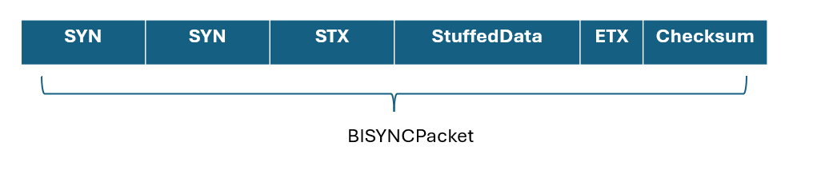
Fig. 1 Customized BISYNCPacket
Where:
- StuffedData = ByteStuffing(originalData), which inserts a DLE before any occurrence of SYN, STX, ETX, or DLE in the original data.
- Checksum = Checksum(StuffedData), ensuring data integrity.
Since a BISYNCPacket may be lost or damaged during transmission, we need to implement flow control by adding a packet number. To achieve this, we introduce three additional fields with the BISYNCPacket as follows:
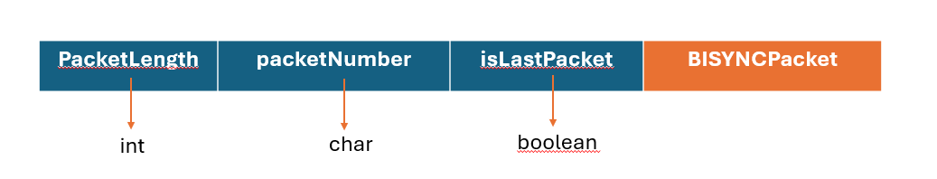
Fig. 2 Add three control fields

- PacketLength (integer): The total number of bytes in the BISYNCPacket.
- PacketNumber (char): The sequence number of the packet.
- isLastPacket (boolean): Indicates whether this is the final packet in the transmission.
For simplicity, we assume that PacketLength, PacketNumber, and isLastPacket remain intact and are not affected by transmission errors.
Since PacketNumber is a char, it has a maximum value of 255. The sequence numbers should cycle as follows:
0, 1, 2, … 255, 0, 1, 2, 3, … 255, 0, 1, …

Starter Code & Testing Files
You are provided with starter code and test files.

Task 1: Implement Byte Stuffing & Unstuffing
- Implement the byteStuff(byte[] data) and byteUnstuff(byte[] unstuffedData) functions in the BISYNCPacket class.
The byteStuff() function inserts a DLE before any occurrence of SYN, STX, ETX, or DLE in the original data to prevent misinterpretation during transmission. The byteUnstuff() function removes the extra DLE characters, restoring the original data before processing.

Task 2: Implement Stop-and-Wait ARQ
- Complete the transmit(List<BISYNCPacket> packets) and start() functions in the StopAndWaitARQ_Sender and StopAndWaitARQ_Receiver classes.

The sender should transmit one packet at a time and wait for an acknowledgment (ACK) before sending the next packet. The receiver should verify each packet’s integrity using the checksum, send an ACK if valid, or a NAK (negative acknowledgment) if an error is detected, ensuring reliable data transmission.
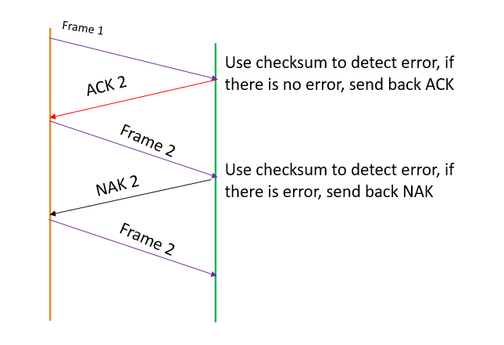
Fig. 3 illustration of customized Stop-and-Wait ARQ
Since we are not implementing timers or multiple threads to handle timeouts, we will customize the Stop-and-Wait ARQ as follows:
- If the receiver detects an error in frame k (using the checksum), it sends back NAK(k), requesting retransmission.
- If the packet is valid, the receiver sends ACK((k+1) mod 256) to acknowledge successful receipt and indicate readiness for the next packet.
Since the maximum packet number is 255, the sequence numbers will cycle accordingly. This process is illustrated in Fig. 3.

Task 3: Implement Selective-Repeat ARQ
- Complete the transmit(List<BISYNCPacket> packets) and start() functions in the SelectiveAndRepeatARQ_Sender and SelectiveAndRepeatARQ_Receiver classes.

Since we are not using timers or multiple threads to handle timeouts, we will simplify and customize the Selective-Repeat ARQ as follows:
- If the receiver receives an in-order frame k, it advances the sliding window and sends back ACK((k+1) mod 256).
- If the receiver gets an out-of-order frame k, it checks for missing frames within its sliding window and sends NAK for each missing frame before k.
- When the sender resends a missing frame, it will not be lost.

Let’s explain the story of the customized Selective-Repeat ARQ with the following example where the size of the sliding window is 4. Here we use W_{s} and W_{r} to represent the sliding window for the sender and the receiver, respectively.
Example Scenario (Fig. 4)
- Initially, the sender and receiver have a sliding window [0, 1, 2, 3].
- The receiver gets frame 0, advances its window W_{r} to [1, 2, 3, 4], and sends back ACK 1.
- Frames 1 and 2 are missing. If the receiver receives frame 3, it does not advance the window. Instead, it detects missing frames 1 and 2 in W_{r} and sends back NAK 1 and NAK 2.
- On receiving ACK 1, the sender advances its window W_{s} to [1, 2, 3, 4] and transmits frame 4 since frames 2 and 3 are on the air.
- If the receiver then gets frame 4, it again detects that frames 1 and 2 are missing in W_{r}. Since NAKs for 1 and 2 were already sent, it does not resend them and waits without sending ACK or NAK.
- Later when the sender receives NAK 1 and NAK 2, it resends frames 1 and 2 and we assume the retransmissions will not get lost.
- Once the receiver finally gets frame 1, it advances the window W_{r} to [2, 3, 4, 5] and sends ACK 2.
- When the receiver later receives frame 2, it advances W_{r} to [5, 6, 7, 8] and sends ACK 5, since frames 0-4 have been received.
- The sender, upon receiving ACK 2, advances its window W_{s} to [2, 3, 4, 5] and transmits frame 5.
- When the sender gets ACK 5, it moves W_{s} to [5, 6, 7, 8] and sends frames 6, 7, and 8 immediately.
This process continues until all frames are successfully transmitted and acknowledged.

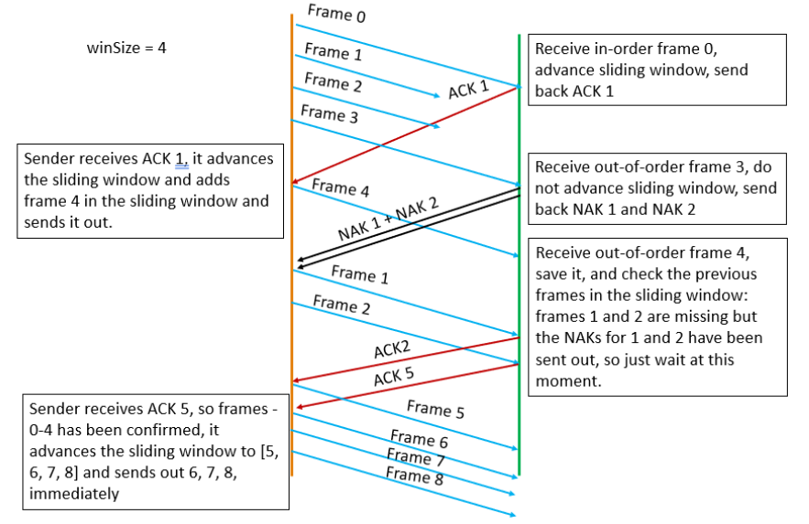
Fig. 4 illustration of customized Selective-and-Repeat ARQ (winSize = 4) where frames 1 and 2 are lost
Task 4: File Transmission Using Stop-and-Wait ARQ
- Transfer the files testText.txt, testImage.jpg, and testVideo.mp4 between two PCs using Stop-and-Wait ARQ with an ERROR_RATE of 0.2.
- Ensure that all files are transmitted correctly and completely.

Task 5: File Transmission Using Selective-Repeat ARQ
- Transfer the same files (testText.txt, testImage.jpg, and testVideo.mp4) using Selective-Repeat ARQ with a LOST_RATE of 0.2 and a window size (WinSize) of 50.
- Verify that the files are transmitted without corruption or missing data.

Task 6: Measure Round Trip Time (RTT) Using tracert with Stop-and-Wait ARQ
- Use the tracert command to estimate the RTT (Round Trip Time) between the sender and receiver and take a snapshot of it.
- For a noticeable RTT, you can place one PC in the dorm and the other in a library or classroom.
- Analyze the number of intermediate nodes (routers) along the path. Below is an example of the snapshot taken between my laptop and desktop.

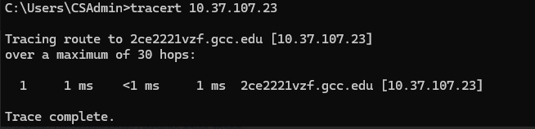
Fig. 5 snapshot of tracert results

Next, use Stop-and-Wait ARQ with an ERROR_RATE of 0.0 to transmit testVideo.mp4. If your code cannot successfully send this file, use testImage.jpg instead.
Record the latency of the transmission and write a brief explanation analyzing the factors affecting the latency.

Task 7: Analyze Window Size vs. Latency with Selective-Repeat ARQ
- Transmit testVideo.mp4 using Selective-Repeat ARQ with a LOST_RATE of 0. If your code cannot successfully send this file, use testImage.jpg instead.
- Perform the transmission three times, adjusting the window size (WinSize) to 10, 50, and 100.
- Record the latency for each transmission and plot a chart to visualize the relationship between window size and latency.
- Your results should resemble the expected trend shown in the reference chart.

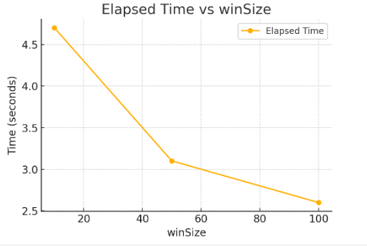
Fig. 6 Latency vs WinSize

Rubric: To receive credit, submit a .zip file via mygcc containing all your source code, a report doc, and a README.txt file, describing how to run the code.

Points will be awarded based on the following:
 | Points
Task 1: Implement Byte Stuffing & Unstuffing | 10
Task 2: Implement Stop-and-Wait ARQ | 25
Task 3: Implement Selective-Repeat ARQ | 25
Task 4: File Transmission Using Stop-and-Wait ARQ | 10
Task 5: File Transmission Using Selective-Repeat ARQ | 10
Task 6: Measure Round Trip Time (RTT) Using tracert and analyze latency with Stop-and-Wait | 10
Task 7: Analyze Window Size vs. Latency with Selective-Repeat ARQ | 10
Bonus: if you submit your solution by Mar. 14 | 10

Your code must execute under IntelliJ. Also, if your code crashes, no partial credit will be given

Modularity is required in the design of your program. Use good software design and engineering techniques, such as procedural abstraction (as appropriate), to increase the extensibility, maintainability, and readability of your code.

In addition, you should include a comments section at the beginning of each of your files that provides information about the file and its intended purpose. For example,

/** Author: David Zhang
* Course: COMP 342 Data Communications and Networking
* Date: 16 March 2025
* Description: put a description here
*/

Without the comment section, 5% grade will be taken away.
The following criteria will be used to grade your submission:

- Does the code function according to the problem specification?
- Is there an appropriate comments section at the beginning of each file (similar to the one shown above)?
- Are there inline comments before each block of code?
- Is the code readable and well-formatted? Is it well-documented and clear?

A program that does not run without crashing will not be graded.

Extensions will not be granted for technology-related issues. Leave yourself enough time to complete the assignment, submit the assignment using mygcc, and contact the instructor if you run into problems.

Project Policies:
- Assignments must be submitted electronically via my.gcc. Be sure to upload your files correctly the first time.
- This project is a group project. Every student needs to work as a part of a 2-person team. If you cannot find a team to work with, contact Dr. Zhang and he will assign you a team. Students are expected to stay in the same team used for Project 1.
- 20% of the grade will be weighed with the peer evaluation. Students are expected to turn in the peer evaluation form posted on mygcc at the end of the semester. If a student works on his or her own without a team, then 20% of the grade will be deducted from the project grade.
- Students are expected to keep the same team for the whole semester.
Academic Integrity Policy:
- Each team is expected to work on its own. Members of each team can work together, discuss ideas, help each other on debugging etc. Please do not attempt to look at each other’s code unless you have to.
- Students belonging to different teams should not discuss, share code that directly bears on this project, or look at each other’s code. Any instances of this will be considered a violation of the academic integrity policy of this course and will be reported to the SFRC committee.
- Use or possession of past solutions and similar solutions from online resources is strictly prohibited and is considered a violation of the academic integrity of this course.
- You may use online resources to look up how to use a function, but you may not copy code from online resources. Any copied code (whether cited or not) is considered a violation of the academic integrity policy of this course.

